UEE410 Submitted by:

Abhiveer Pathania

102354005

3D12

Assignment 1

// Question 1: Write a program to convert miles into kilometers (Km). Hint: 1 Mile = 1.609 Km. [Use macros, relevant name and types for variables].

#include <stdio.h>

#define MILE_TO_KM_CONVERSION_FACTOR 1.609

int main() {

    float miles;

    float kilometers;

    printf("Enter the distance in miles: ");

    scanf("%f", &miles);

    kilometers = miles * MILE_TO_KM_CONVERSION_FACTOR;

    printf("%.2f miles is equal to %.2f kilometers.\n", miles, kilometers);

    return 0;

}

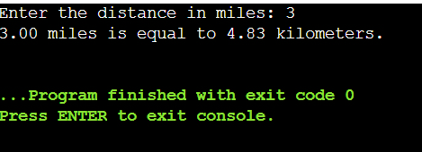

// Question 2: Write a program to find the number of positive, negative and zeros in a sequence of inputs (numbers) entered as data.

#include <stdio.h>

int main() {

    int num, positive_count = 0, negative_count = 0, zero_count = 0;

    char choice;

    do {

        printf("Enter a number: ");

        scanf("%d", &num);

        if (num > 0) {

            positive_count++;

        } else if (num < 0) {

            negative_count++;

        } else {

            zero_count++;

        }

        printf("Do you want to enter another number? (y/n): ");

        scanf(" %c", &choice);

    } while (choice == 'y' || choice == 'Y');

    printf("Number of positive numbers: %d\n", positive_count);

    printf("Number of negative numbers: %d\n", negative_count);

    printf("Number of zeros: %d\n", zero_count);

    return 0;

}

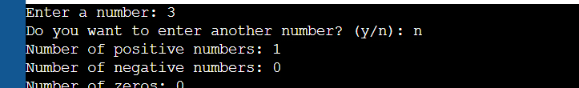

// Question 3: Compute the tax due based on a tax table given below:

// Program Input: Salary amount

// Program Output: Returns the tax due for 0.0 <= salary <= 150,000.00; returns -1.0 if salary is outside the table range.

#include <stdio.h>

int main() {

    double salary, tax = -1.0;

    printf("Enter your salary amount: ");

    scanf("%lf", &salary);

    if (salary < 0.0 || salary > 150000.00) {

        printf("Tax due: %.2lf\n", tax);

    } else if (salary <= 14999.99) {

        tax = salary * 0.15;

    } else if (salary <= 29999.99) {

        tax = 2250.00 + (salary - 15000.00) * 0.18;

    } else if (salary <= 49999.99) {

        tax = 5400.00 + (salary - 30000.00) * 0.22;

    } else if (salary <= 79999.99) {

        tax = 11000.00 + (salary - 50000.00) * 0.27;

    } else { // salary <= 150000.00

        tax = 21600.00 + (salary - 80000.00) * 0.33;

    }

    if (tax != -1.0) {

        printf("Tax due: %.2lf\n", tax);

    }

    return 0;

}



// Question 4: Write an interactive program (menu driven) in 'C' (using functions) to compute the area of a selected geometrical figure (from a list of such figures (square, rectangle, and circle).

#include <stdio.h>

#include <math.h>

// Function to calculate area of a square

float areaOfSquare() {

    float side;

    printf("Enter the side length of the square: ");

    scanf("%f", &side);

    return side * side;

}

// Function to calculate area of a rectangle

float areaOfRectangle() {

    float length, width;

    printf("Enter the length and width of the rectangle: ");

    scanf("%f %f", &length, &width);

    return length * width;

}

// Function to calculate area of a circle

float areaOfCircle() {

    float radius;

    printf("Enter the radius of the circle: ");

    scanf("%f", &radius);

    return M_PI * radius * radius;

}

int main() {

    int choice;

    float area;

    do {

        printf("\nMenu:\n");

        printf("1. Calculate area of a Square\n");

        printf("2. Calculate area of a Rectangle\n");

        printf("3. Calculate area of a Circle\n");

        printf("4. Exit\n");

        printf("Enter your choice: ");

        scanf("%d", &choice);

        switch (choice) {

            case 1:

                area = areaOfSquare();

                printf("Area of the square: %.2f\n", area);

                break;

            case 2:

                area = areaOfRectangle();

                printf("Area of the rectangle: %.2f\n", area);

                break;

            case 3:

                area = areaOfCircle();

                printf("Area of the circle: %.2f\n", area);

                break;

            case 4:

                printf("Exiting program.\n");

                break;

            default:

                printf("Invalid choice. Please try again.\n");

        }

    } while (choice != 4);

    return 0;

}

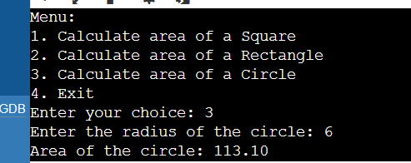

// Question 5: Write a program to display first n elements of Fibonacci series.

#include <stdio.h>

int main() {

    int n, first = 0, second = 1, next, i;

    printf("Enter the number of Fibonacci elements to display: ");

    scanf("%d", &n);

    printf("Fibonacci series up to %d elements:\n", n);

    for (i = 0; i < n; i++) {

        if (i <= 1) {

            next = i;

        } else {

            next = first + second;

            first = second;

            second = next;

        }

        printf("%d ", next);

    }

    printf("\n");

    return 0;

}

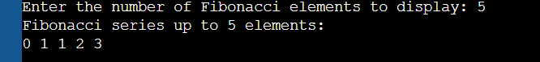

// Question 6: Write a program to print a table book from Table X to Table Y. X and Y are user inputs.

#include <stdio.h>

int main() {

    int start_table, end_table, i, j;

    printf("Enter the starting table number: ");

    scanf("%d", &start_table);

    printf("Enter the ending table number: ");

    scanf("%d", &end_table);

    for (i = start_table; i <= end_table; i++) {

        printf("\nMultiplication Table for %d:\n", i);

        for (j = 1; j <= 10; j++) {

            printf("%d x %d = %d\n", i, j, i * j);

        }

    }

    return 0;

}

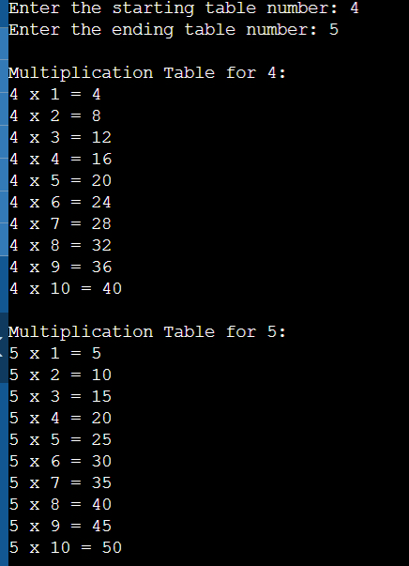

// Question 7: Write a program to compute factorial of a number using iterative approach.

#include <stdio.h>

int main() {

    int num, i;

    long long factorial = 1;

    printf("Enter a number to compute its factorial: ");

    scanf("%d", &num);

    if (num < 0) {

        printf("Factorial of a negative number doesn't exist.\n");

    } else {

        for (i = 1; i <= num; i++) {

            factorial *= i;

        }

        printf("Factorial of %d is %lld.\n", num, factorial);

    }

    return 0;

}

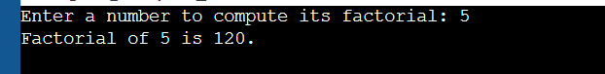

// Question 8: Write a program to swap two numbers using functions.

#include <stdio.h>

void swap(int *a, int *b) {

    int temp = *a;

    *a = *b;

    *b = temp;

}

int main() {

    int num1, num2;

    printf("Enter two numbers to swap: ");

    scanf("%d %d", &num1, &num2);

    printf("Before swapping: num1 = %d, num2 = %d\n", num1, num2);

    swap(&num1, &num2);

    printf("After swapping: num1 = %d, num2 = %d\n", num1, num2);

    return 0;

}

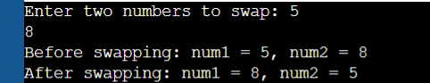

// Question 9: Write a function that returns the first integer between n_min and n_max entered as data to the calling function (main).

#include <stdio.h>

int findFirstInRange(int min, int max) {

    int num;

    while (1) {

        printf("Enter a number: ");

        scanf("%d", &num);

        if (num >= min && num <= max) {

            return num;

        }

        printf("Number is not in the range [%d, %d]. Please try again.\n", min, max);

    }

}

int main() {

    int n_min, n_max;

    printf("Enter the minimum and maximum range: ");

    scanf("%d %d", &n_min, &n_max);

    int first_in_range = findFirstInRange(n_min, n_max);

    printf("The first number entered within the range [%d, %d] is: %d\n", n_min, n_max, first_in_range);

    return 0;

}

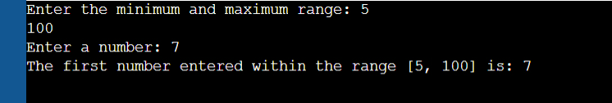

// Question 10: Write nests of loops that cause the following output to be displayed.

/*

0

0 1

0 1 2

0 1 2 3

0 1 2 3 4

0 1 2 3 4 5

0 1 2 3 4

0 1 2 3

0 1 2

0 1

0

*/

#include <stdio.h>

int main() {

    int i, j;

    // Upper part of the pattern

    for (i = 0; i <= 5; i++) {

        for (j = 0; j <= i; j++) {

            printf("%d ", j);

        }

        printf("\n");

    }

    // Lower part of the pattern

    for (i = 4; i >= 0; i--) {

        for (j = 0; j <= i; j++) {

            printf("%d ", j);

        }

        printf("\n");

    }

    return 0;

}

